Galileo Galilei
(1564-1642)

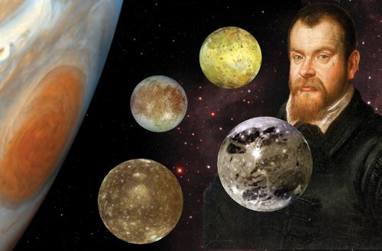
Galileo Galilei – most people simply call him Galileo – was one of the most significant people in the history of science. He lived at a crucial crossroads in time when different strands of thought met and clashed. These were:
- natural philosophy based on Aristotle’s incorrect ideas.
- the beliefs of the Catholic Church at the time.
- evidence-based scientific research.

In the end, the ideas of Galileo and other scientists triumphed, because they were able to prove them to be true.
Although his ideas triumphed, Galileo paid a high price for his science: he spent the last eight years of his life under house arrest, and the Catholic Church banned the publication of anything written by him.

Galileo’s Scientific Achievements and Discoveries
- Was the first person to study the sky with a telescope.
- Became a skilled telescope builder and made money selling them to merchants in Venice who were eager to see which ships were arriving as soon as possible in an effort to make money on the ‘futures’ market.
- Discovered the first moons ever known to orbit a planet other than Earth. Jupiter’s four largest moons, which he discovered: Io, Europa, Ganymede, and Callisto, are together known as the Galilean Satellites in his honor.
- Discovered that Venus has phases like the moon, ranging from a thin crescent to full. This was the first practical, observational evidence that the sun sits at the center of the Solar System, orbited by the planets.
- Discovered the rings of Saturn, although he found their appearance very confusing.
- Discovered our moon has mountains.
- Discovered that the Milky Way is made up of stars.

- We now know from drawings in his notebook, the first person ever to see the planet Neptune. He observed that, unlike the other stars, it was moving. In Galileo’s time, the planets Mercury, Venus, Mars, Jupiter and Saturn had been known of for thousands of years and no others were contemplated. Galileo lost track of the moving star he had found. Neptune was not discovered until 1846.
- Established that, if there is no air resistance, everything falls to the ground at the same rate regardless of its weight. Gravity accelerates all objects equally, whatever their mass.
- Established that when gravity accelerates any object, the object accelerates at a constant rate so that the distance fallen is proportional to the time squared. For example, a ball falling for one second would travel a distance of one unit; a ball falling for two seconds would travel a distance of four units; a ball falling for three seconds would travel a distance of nine units, etc. It is probably a myth that he discovered this by dropping cannon balls from the Leaning Tower of Pisa. He used balls rolling down wooden ramps for most of his investigations of gravity and acceleration.
- Identified that anything thrown or fired on Earth, such as a rock or a cannonball, flies along a curved path and that the shape of the curve is a parabola.
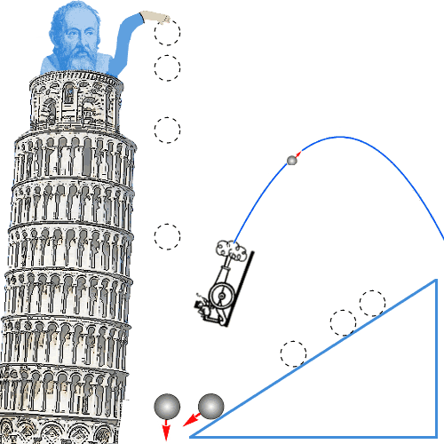

Nicolaus Copernicus
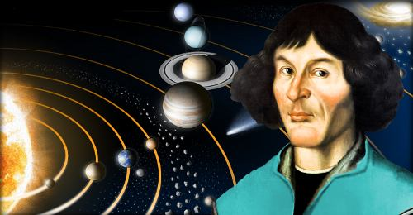
(1473 - 1543)

By publishing his evidence that Earth orbits the sun, Nicolaus Copernicus relegated our planet’s status from center of the universe to just another planet. In doing so, he began the scientific revolution.

Discovering Flaws in Current Astronomy
It’s worth reminding ourselves that astronomers in those days worked with the naked eye. Galileo Galilei was the first person to look at the heavens with a telescope, and Galileo wasn’t born until Copernicus had been dead for over 20 years.
One of the books in Copernicus’s collection was Summary of Ptolemy’s Almagest by Johannes Regiomontanus.
Claudius Ptolemy’s work, which had been written in Greek, had been the final word in all matters astronomical for over 1300 years. Copies of the Almagest had come to Europe from the Arab world. Astronomers like Johannes Regiomontanus suspected errors had crept in when translations had been made from Ptolemy’s Greek into Arabic and then from Arabic into Latin, the language of educated Europeans.
Regiomontanus obtained copies of Ptolemy’s work in the original Greek and translated them directly into Latin.
It turned out that the errors were actually present in Ptolemy’s original work.
And now Copernicus gathered his thoughts:
• He had read Regiomontanus, who showed Ptolemy had made errors.
• He had observed and discussed the heavens with Domenico Maria Novara, a friend, who told him Ptolemy had made errors.
• He had also heard the opinions of other Italian academics, such as Alessandro Achillini, who had written a book casting doubt on Ptolemy’s work.
If Ptolemy could be wrong about something as basic as the moon’s orbit, then maybe he’d messed up other stuff too. Everything in astronomy could be up for grabs!
For example, Ptolemy had said Earth was at the center of the universe – the so-called geocentric doctrine. Could that be wrong too?
It was clear to Copernicus that Ptolemy was not the final word in astronomy. One day, perhaps he could add some words of his own.

The Heliocentric Universe
Back in Warmia, in 1503, Copernicus worked on astronomy when he could, but he was usually busy with other duties.
Nevertheless, by 1514, he had seen enough in the sky and thought enough about his observations to circulate a few pages with the title Commentariolus – The Little Commentary to people he trusted.
In this hand-written document he put forward his new view of the universe. He thought people should shift from a geocentric (earth centered) view to a heliocentric (sun centered) view.
He took as the basic starting points of his theory:
• The earth is not the center of the universe.
• The center of the universe is near the sun.
• The Earth-Sun distance is negligible compared to the distance to the stars.
• Earth’s rotation accounts for the apparent daily rotation of the stars.
• The apparent annual cycle of movements of the sun is caused by the earth orbiting it.
• The apparent retrograde motion of the planets is caused by the motion of the Earth from which one observes the planets.
With these starting points, he had relegated our planet from a special, highly privileged position at the center of the universe, to nothing very special – another planet moving around the sun. This was potentially dangerous, because a lot of people held the view that:
• passages in the Bible imply that the earth does not move
• the Bible is the word of God
• the penalty for disagreeing with God is death
Of course, at this time, Copernicus had revealed his new theory of the universe to just a small number of trusted friends. You’re not going to begin a scientific revolution doing that!
On the other hand, in those days it was best not to broadcast your heretical beliefs too widely, not if you valued your life – even if you did ‘scorn the judgment’ of the people who were burning you at the stake!
As support for the truth of Copernicus’s heliocentric theory began to grow stronger, the Catholic Church, sensing a threat to its supremacy, declared that support for heliocentrism was heresy. In 1616 the Church banned Copernicus’s book completely.
In 1620 the Church approved Copernicus’s book after editing it: any sentences in which Copernicus wrote about a moving Earth and a central Sun as a matter of fact were removed or changed. Despite the final approval, the book was still not actually published in any countries with a powerful Catholic Church.
Nevertheless, support for Copernicus continued to grow, and his ideas triumphed over those of his opponents. It was a victory for evidence based, observational science, interpreted using the language of nature – mathematics.
Francis Bacon
(1561-1626)
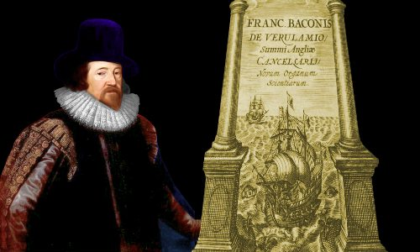
Francis Bacon discovered and popularized the scientific method, whereby the laws of science are discovered by gathering and analyzing data from experiments and observations, rather than by using logic-based arguments.
The Baconian method marked the beginning of the end for the 2,000-year-old natural philosophy of Aristotle, unleashing a wave of new scientific discoveries, particularly in the hands of devotees such as Robert Boyle.
Bacon produced a large body of scientific work. His science produced no world-changing results, but his guidelines for how science should be carried out did.
It was obvious to Bacon that Europe in the early 1600s enjoyed significantly better technology than the classical world had. For example, the printing press had democratized knowledge; gunpowder had made armies much more powerful; and the magnetic compass had facilitated better navigation and the discovery of the Americas.
He found it monumentally frustrating that people’s intellectual understanding of the world had not progressed beyond that of the Ancient Greeks’.

Throwing Out Aristotle
The attitude of most scholars in the early 1600s was, in short, that after you had mastered what Aristotle had to say about Nature, you knew everything. You could then go off and do something else.
Bacon’s objective was to replace Aristotle and Plato’s works, which were based on logical and philosophical arguments, with a new body of scientific knowledge secured by experiments and observations.
He also objected to the tendency of Aristotle, Plato, and others including Pythagoras to mix scientific ideas with religious ideas. Bacon believed that the two should be kept separate. He was highly suspicious of people who said the laws of nature were there as part of a greater purpose. He thought they were there to be discovered and, if possible, exploited.

The Inductive Method
Bacon championed the inductive method in science. This means you move from specific facts to a general rule. You do not start with a hypothesis or theory.
Aristotle, on the other hand, used the deductive method. He would move from a general rule to specific facts. He started with rules he had developed from logical arguments.
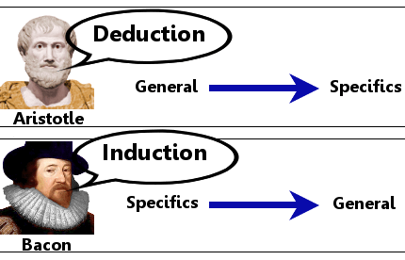

The Scientific Method Today – The Hypothetico Deductive Method
Bacon’s ideas are still used today – the vital importance to science of experimental data and observations are now beyond doubt.
Nowadays many scientists use the Hypothetico Deductive Method. The basis of this method is that a scientist states a hypothesis and then uses data to establish whether the hypothesis is true or false. When using this method it is important that the hypothesis is written in such a way that clear criteria are stated which would establish its falseness.

Isaac Newton
(1643-1727)

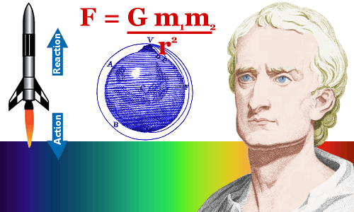
Isaac Newton is perhaps the greatest physicist who has ever lived. He and Albert Einstein are almost equally matched contenders for this title.
Each of these great scientists produced dramatic and startling transformations in the physical laws we believe our universe obeys, changing the way we understand and relate to the world around us.

Some Details about Newton’s Greatest Discoveries
Newton revealed his laws of motion and gravitation in his book the Principia. Just as few people at first could understand Albert Einstein’s general theory of relativity, few people understood the Principia when it was published. When Newton walked past them one day, one student remarked to another:
“There goes a man who has written a book that neither he nor anybody else understands.”

Calculus
Newton was the first person to fully develop calculus. Calculus is the mathematics of change. Modern physics and physical chemistry would be impossible without it. Other academic disciplines such as biology and economics also rely heavily on calculus for analysis.
From Newton’s fertile mind came the ideas that we now call differential calculus, integral calculus and differential equations.
Soon after Newton generalized calculus, Gottfried Leibniz achieved the same result. Today, most mathematicians give equal credit to Newton and Leibniz for calculus’s discovery.

Universal Gravitation and the Apple
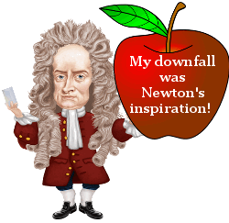
Newton’s famous apple, which he saw falling from a tree in the garden of his family home in Woolsthorpe-by-Colsterworth, is not a myth.
He told people that seeing the apple’s fall made him wonder why it fell in a straight line towards the center of our planet rather than moving upwards or sideways.
Ultimately, he realized and proved that the force behind the apple’s fall also causes the moon to orbit the earth; and comets, the earth and other planets to orbit the sun. The force is felt throughout the universe, so Newton called it Universal Gravitation. In a nutshell, it says that mass attracts mass.
Newton discovered the equation that allows us to calculate the force of gravity between two objects.

Newton’s Laws of Motion
Newton’s three laws of motion still lie at the heart of mechanics.
First law: Objects remain stationary or move at a constant velocity unless acted upon by an external force. This law was actually first stated by Galileo, whose influence Newton mentions several times in the Principia.
Second law: The force F on an object is equal to its mass m multiplied by its acceleration: F = ma.
Third law: When one object exerts a force on a second object, the second object exerts a force equal in size and opposite in direction on the first object.
With Newton’s calculus, universal gravitation, and laws of motion, you have enough knowledge at your fingertips to plot a course for a spaceship to any planet in our solar system or even another solar system!
And Isaac Newton figured it all out about 300 years before we actually did send a spaceship to the planets.

René Descartes
(1596-1650)
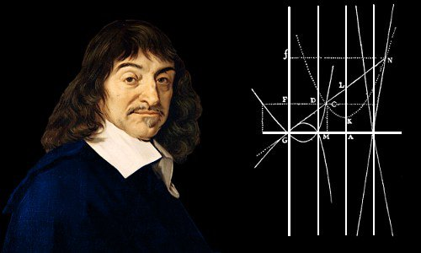
René Descartes invented analytical geometry and introduced skepticism as an essential part of the scientific method. He is regarded as one of the greatest philosophers in history.
His analytical geometry was a tremendous conceptual breakthrough, linking the previously separate fields of geometry and algebra. Descartes showed that he could solve previously unsolvable problems in geometry by converting them into simpler problems in algebra. He represented the horizontal direction as x and the vertical direction as y. This concept is now indispensable in mathematics and most other sciences.
René Descartes’ Contributions to Science

The Miracle
On November 10, 1619 Descartes was dozing in a warm, stove-heated room in the German town of Neuburg an der Donau.
There he had a series of dreams that would ultimately change the way scientists work. He believed a spirit sent by God had given him new ideas about:
- The Scientific Method
- Analytical Geometry
- Philosophy
18 years later, in 1637, he published his ideas in Discours de la mèthode (Discussion of the Method), La Gèomètrie (Geometry), Les Mètèores (Meteorology), and La Dioptrique (Optics). The first two of these works contain his most significant contributions.

The Method
In Discussion of the Method Descartes shared his framework for doing science.
One of his main lines of thought was skepticism – that everything should be doubted until it could be proved.
His four main ideas for scientific progress were:
1. Never accept anything as true until all reasons for doubt can be ruled out.
2. Divide problems into as many parts as possible and necessary to provide an adequate solution.
3. Thoughts should be ordered, starting with the simplest and easiest to know, ascending little by little, and, step by step, to more complex knowledge.
4. Make enumerations so complete, and reviews so general, that nothing is omitted.
It is ironic that Descartes’ own method might lead us to doubt that a dream 18 years earlier could have been the true source of his ideas!

Analytical Geometry
Descartes made the revolutionary discovery that he could solve problems in geometry by converting them into problems in algebra.
In La Gèomètrie he showed that curves could be expressed in terms of x and y on a two-dimensional plane and hence as equations in algebra.
By unleashing the mathematical power of algebra to tackle problems in geometry, Descartes surpassed the expertise of Ancient Greece’s brilliant geometers: he could now solve problems that had defeated them.

Influencing Isaac Newton and the Invention of Calculus
Calculus has been crucial to the progress of mathematics and the sciences. It was developed in the 1660s by Isaac Newton, and developed independently in the 1670s by Gottfried Leibniz.
In La Gèomètrie, Descartes showed how he could find tangents to curves. This process is a vital part of differential calculus. His mathematical competitor Fermat was also able to find tangents to curves; his methods were actually simpler than Descartes’. Both Descartes and Fermat helped guide Newton and Leibniz’s development of calculus.

Philosophy
Descartes is regarded as one of the greatest philosophers of all time. Here we are concerned with science rather than philosophy, so we will restrict ourselves to noting his most famous declaration:
“I think therefore I am.”
This could also be expressed as:
“I can think, therefore I exist.”
Descartes regarded this statement as the unshakeable foundation that all other philosophy could be built upon.
His most famous philosophical work is Meditations on First Philosophy, published in 1641.

